China’s Expanding Influence in the Bay of Bengal

A Strategic Resilience Group Information Awareness Piece- October 10, 2025

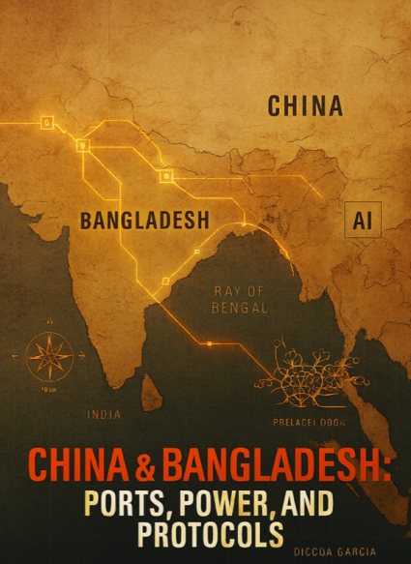
China’s exploitation of Bangladesh is leading to opportunities for the PLA Navy to harass and intimidate in the Bay of Bengal. Mongla handled 171 overseas vessels in the 2½ months to September 21, and Chattogram posted ~12% year-over-year throughput growth in Q1 FY26 (July–September).

As of early October 2025, Beijing’s courtship of Dhaka has visibly intensified—Chinese officials are advancing technical scoping on the Teesta master plan while Bangladesh’s port build-out continues at pace, and China’s Yuan Wang-5 tracking vessel re-enters the wider Indian Ocean.

In August 2022 Mustafa Kamal, then the finance minister for Bangladesh, warned developing countries about the risk of China’s Belt and Road Project loans. He expressed deep concern over poor lending practices and overwhelming indebtedness. At the time of his interview, Bangladesh owed China USD 4 billion, which equated to roughly 6 percent of its foreign debt. Bangladesh’s debt to China has surged to USD 7 billion, nearly doubling in three year.

Bangladesh also replaced its finance minister. Abdul Hassan Mahmood Ali, now holds that position and he has a long and developed relationship with China. Abdul Hassan served as the Chief of Mission at the Embassy of Bangladesh in Beijing from 1983 to 1986 and led the way to China’s investment in the Barapukuria coal mine project. Bangladesh’s interim government, led by Muhammad Yunus, has signaled a deepening alignment with Beijing.

Yunus met with President Xi Jinping on March 28, 2025 in an effort to reinforce its relationship with Communist China and likely to solidify an additional USD 5 billion soft loan from China, which would raise the dept to USD 12 billion.

Yunus is hopeful China will increase investments in Bangladesh to revive its economy, which is in disrepair due to both political and economic crises. He encouraged collaboration in infrastructure, renewable energy, and trade, highlighting Bangladesh's potential as a manufacturing hub. Most importantly, he reminded Xi that his country’s strategic position provided opportunities for China to expand its influence and solidify presence in an area that is strategically important to the United States.

China has strategically invested in Bangladesh, focusing on two key ports—Chattogram and Mongla—to expand its maritime footprint. The Chattogram Port is part of China's broader Belt and Road Initiative (BRI) and strategically important because of northern location within the Bay of Bengal. In fact, in October 2024, a Chinese naval fleet, including the ships Qi Jiguang and Jing Gangshan, made a goodwill visit to the port, where bilateral meetings focused on naval cooperation between the two countries.

China’s financial entanglement with Bangladesh is not merely economic—it serves a broader strategic purpose, particularly in maritime security. Recently, China pledged $400 million to modernize Bangladesh’s second largest port in Mongla. Projects include boosting the port's capacity and efficiency, which are also in line with China's strategic interests in the Bay of Bengal. China’s navy has not visited this port and that is likely the reason for the significant investment in capacity and efficiency, as these changes will make the port available for naval access.

So why keep throwing money at Bangladesh? What does China want? Xi is making a strategic move to enhance influence in South Asia and secure alternative routes in trade. The Bay of Bengal offers an option to the Malacca Strait, which can easily be blockaded due to narrow navigation through the region. Control and influence in Bengal will also allow China to connect Myanmar-Yunnan oil and gas pipelines to an easy distribution center.

Leverage through extreme debt allows Xi to project naval power, counter India's influence in the region and set Communist China up as a leader in the Global South. To this point, India issued a NOTAM for a likely Bay of Bengal missile test on September 24–25, a window that overlapped with the return of China’s Yuan Wang-5 to the Indian Ocean—underlining the cat-and-mouse dynamic both sides now take for granted.

As a result of China’s continued encroachment, India has increased its naval presence in the Bay of Bengal, conducting regular patrols and participating in joint naval exercises like the Malabar Exercise with the U.S., Japan, and Australia; all aimed to maintain a free and open Indo-Pacific.

The Kaladan Multi-Modal Transit Transport Project will provide an alternate route to the Siliguri Corridor (Chicken's Neck) and enhance connectivity to India's northeastern states. India hopes to connect Kolkata with Myanmar's Sittwe Port via the Bay of Bengal. Additionally, India is enhancing its naval and air presence in the Bay of Bengal through infrastructure upgrades on Andaman and Nicobar Islands. Both serve key roles in India’s naval operations which focus on maritime security and surveillance in the region.

For the CCPs part they continue to disrupt the Kaladan project by supporting the Arakan Army, an insurgent group in Myanmar. The group reportedly has access to Chinese weapons and additional funding from Chinese linked organizations; much of which is used to disrupt crucial road work and project timelines.

Xi also sees India’s work on Andaman and Nicobar as a challenge to its “String of Pearls” strategy, which is part of China’s port network. As a result, more BRI money continues to flow into ports like Hambantota and Gwadar, to counter India.

In the end, Beijing’s strategy in the Bay of Bengal is not confined to ports, loans, or naval access. It also relies on information operations that promote BRI projects as indispensable while dismissing debt concerns, and on disinformation that casts India’s initiatives as destabilizing or externally imposed. These narratives, layered atop physical investments, help China counter Western and Indian influence and normalize its expanding presence across the Bay of Bengal and the wider Global South.

